Gulf Coast Province Summer Assembly 2018 Agenda
Hosted by Delta Gamma - Auburn University
Host Hotel: Hilton Garden Inn Auburn/Opelika
2555 Hilton Garden Drive, Auburn, AL 36830
Attire: Casual – all weekend. Kappa Psi related clothing preferred during meetings

Friday, June 1st, 2018

  - 6:00- 8:30 PM ~ Registration
      - Location: Walker Building Atrium
      - Address: 2316 Walker Building, Auburn, AL 36849
      - Recommended transportation: Personal
      - Parking lot: Behind School (along War Eagle Way), PC 3, or Lowder Parking Lot (Business School) see map at the bottom.
  - 8-11 PM ~ Evening Social Event
      - Good Times (Bowling Alley/Arcade)
      - Location: 750 East Glenn Ave, Auburn, AL 36830
      - Attire: Casual

Saturday, June 2nd, 2018
  - 8:00 - 9:00 AM ~ Registration/Breakfast: Panera
      - Location: Walker Building Atrium
        - Address: 2316 Walker Building, Auburn, Al 36849
        - Parking lot: Behind the School (along War Eagle Way), PC 3, or Lowder Parking Lot (Business School) see map at bottom.
  - 9:00 AM - 10:30 AM ~ Business Session
          - Opening Ritual
          - Roll Call
- Minutes 2018 Winter (posted online and emailed prior to meeting)
- Correspondence
        - Recognition of visiting brothers from Satrap Julianne Willis
        - House Updates - Perry Thompson
        - Officer Reports
- Committee Reports
- Legislative update (10:00 AM to 10:30 AM)
  - D.J. Onuaguluchi
  - Location: Walker Building Flat (1106)
  - Attire: Casual
  - 10:45 AM - 11:45 AM ~ Roundtable Development Seminars Session # 1
      - Roundtable 1: Ritual
          - Presenter: Todd Harris
          - Location: 1206
      - Roundtable 2: Philanthropy and Fundraising
          - Presenter: Wade Dickerson and Brooke Gooderham
          - Location: 1315
      - Roundtable 3: Membership and Recruitment
          - Presenter: Fernando Diggs
          - Location: Walker Flat (1106)
      - Roundtable 4: Alumni Relations
          - Presenter: Julianne Willis
          - Location: 1114
  - 11:50 PM to 1:00 PM ~ Lunch: Byron’s BBQ
  - 1:00 PM - 1:20 PM ~ Philanthropy Overview
      - Presenter: Wade Dickerson
      - Sign up for Philanthropy if not already done
      - Location: Walker Building Flat (1106)
  - 1:20 PM - 1:40 PM~ Resolutions and Awards
      - Resolutions
        - Presenter: D.J. Onuaguluchi
        - Location: Walker Building Flat (1106)
- Awards
- Announce next chapter for conclave
  - 1:45 PM - 2:45 PM ~ Roundtable Development Seminars Session # 2
      - Roundtable 1: Ritual
          - Presenter: Todd Harris
          - Location: 1206
      - Roundtable 2: Philanthropy and Fundraising
          - Presenter: Wade Dickerson and Brooke Gooderham
          - Location: 1315
      - Roundtable 3: Membership and Recruitment
          - Presenter: Fernando Diggs
          - Location: Walker Flat (1106)
      - Roundtable 4: Alumni Relations
          - Presenter: Julianne Willis
          - Location: 1114
  - 2:50 PM to 3:00 PM
      - Remaining House Updates
      - Closing of Meeting
      - Location: Room 101
  - 3:05 PM - 4:05 PM ~ CE Session
      - Presenter: Dr. Durham
        - Antimicrobial Stewardship
      - Location: Flat Auditorium
  - 4:10 PM to 5:45 PM ~ Free Time
  - 6:00 PM to 7:15 PM ~ Dinner: Niffer’s Catering
      - Location: Walker Building Flat (1106)
      - Attire: Casual
      - Recommended Transportation: Self Parking
  - 8:00 PM to 11:00 PM ~ Evening Social Event
      - Location: Sky Bar (Downtown Auburn)
      - Recommended Transportation: Uber/Lyft

Sunday, June 3rd, 2018

- 10:00 AM Suggested Brunch Time
    - Suggested Locations: The Hound ($), Acre ($$), Live Oaks ($), The Depot ($$)

Parking: S. Donahue will be CLOSED for construction. Please Use War Eagle Way to gain entrance to the parking lots.

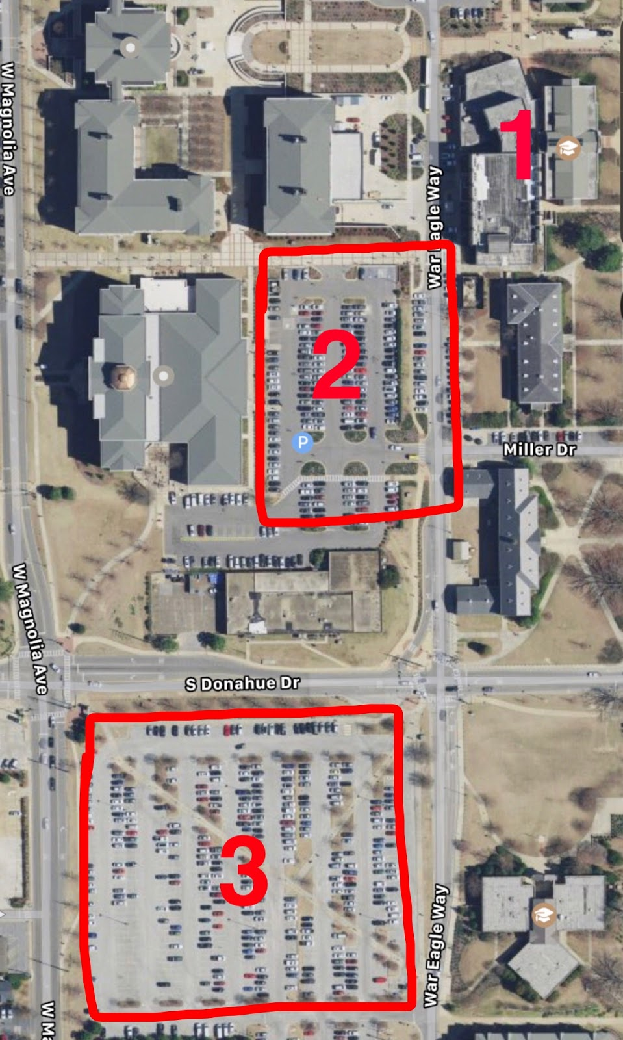

#1=Walker Building (can park along War Eagle Way)
#2=Lowder Parking Lot
#3=PC3 Parking Lot

