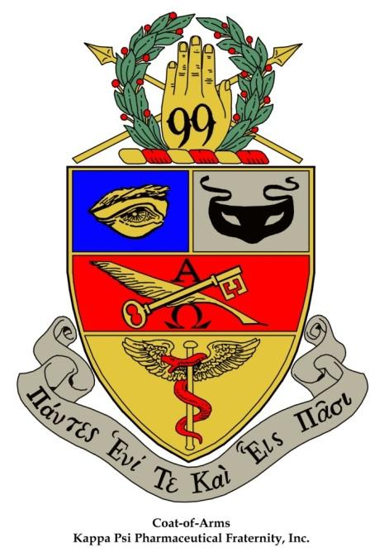
Kappa Psi Pharmaceutical Fraternity
Proxy Form for Gulf Coast Province Winter Assembly
Virtual Assembly
Hosted by Gulf Coast Province February 19th, 2022
The undersigned officers, acting under the direction of the membership of ________________________________ Chapter of Kappa Psi Pharmaceutical Fraternity bestow their voting privileges on the duly elected delegates of __________________________________ Chapter for the Gulf Coast Province Winter Assembly Virtually on February 19th, 2022.

Regent (print/sign) Date

Secretary (print/sign) Date

