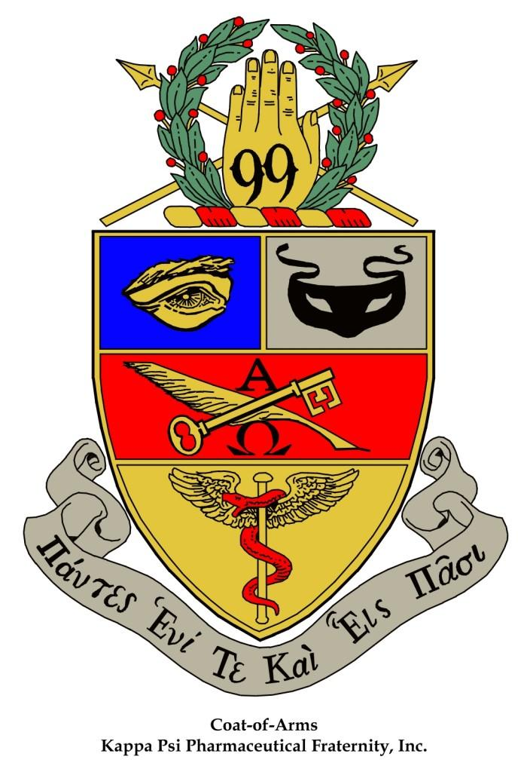
Kappa Psi Pharmaceutical Fraternity
Listing of Delegates and Alternate Delegates
For the Gulf Coast Province Winter Assembly

Virtual February 19th,2022

________________________________________________ Chapter

Delegate: _____________________________________________________________________________________________

Delegate: _____________________________________________________________________________________________

Alternate Delegate: ________________________________________________________________________________

Alternate Delegate: ________________________________________________________________________________

Regent (print & sign) Date

Secretary (print & sign) Date

